Description: This query execution is to visualize the temperature data of two city called SZ(Shenzhen) and SH(Shanghai), which includes collect the address, city, information about collectors, and the temperature data.

How to setup:

- download XAMPP for windows and install. D:/XAMPP
- Download Pchart and copy it to the directory D:/XAMPP/htdocs
- Copy show.php and test.php to directory D:/XAMPP/htdocs
- Run XAMPP and APACHE server and MYSQL.

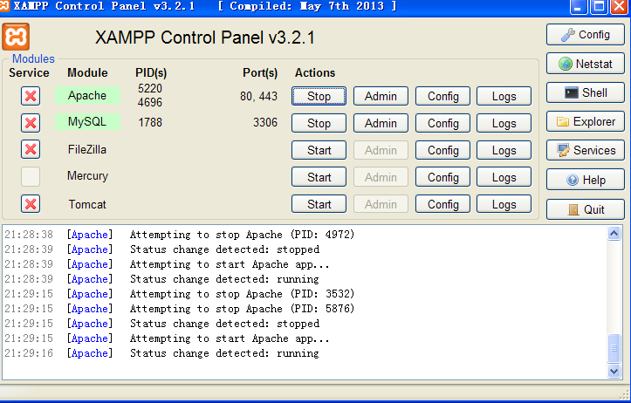

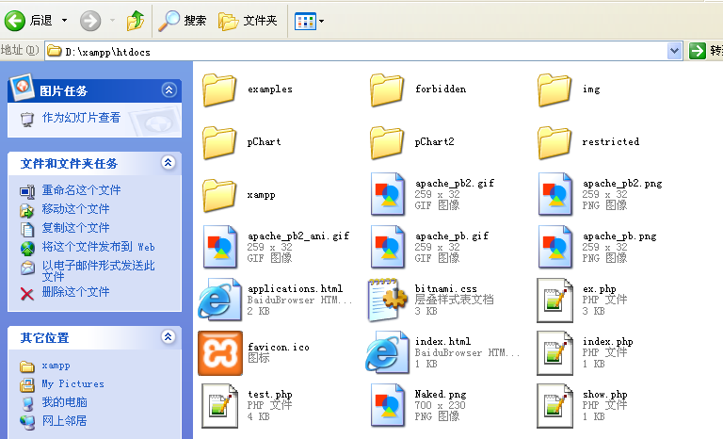

What’s the database structure.

mysql_query("INSERT INTO Persons(Id_P,LastName,FirstName,Address,City)
Id_P stand for the temperature of the city

The temperature is randomly generated between 10 and 40. there are 40 samples for each city

And there are temperatures for two cities.SZ and SH.

for ($i=0; $i<=40; $i++)###40
{

$a=rand(10,40);
mysql_query("INSERT INTO Persons(Id_P,LastName,FirstName,Address,City)
VALUES('$a','Devin','X','xusihong649897@163.com','SZ')",$con);

$a=rand(10,40);
mysql_query("INSERT INTO Persons(Id_P,LastName,FirstName,Address,City)
VALUES('$a','Devin','X','xusihong649897@163.com','SH')",$con);
}

Each Time when you click Generate database, the data will be reset in the below.

mysql_query("CREATE DATABASE IF NOT EXISTS my_db",$con);
mysql_select_db("my_db", $con);
mysql_query('use my_db',$con);
mysql_query('drop table if EXISTS Persons',$con);
mysql_query("CREATE TABLE Persons(
Id_P int,
LastName varchar(255),
FirstName varchar(255),
Address varchar(255),
City varchar(255)
)",$con);

